**STUDENT REGISTRATION SYSTEM**

System to add, delete and update student record

File Structure:

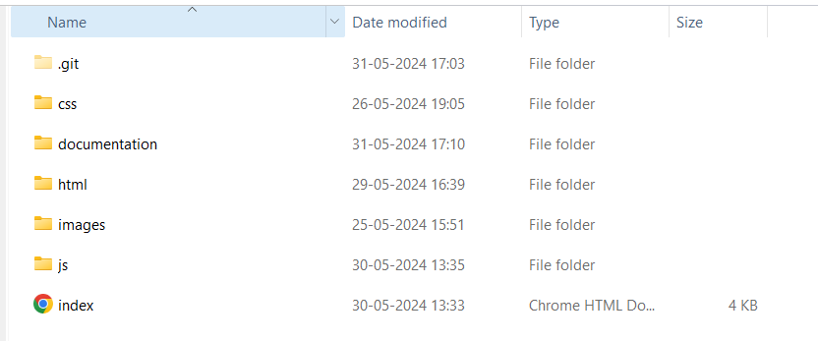

Index.html

Javascript files

HTML files

CSS stylesheet

index.html -> Home page

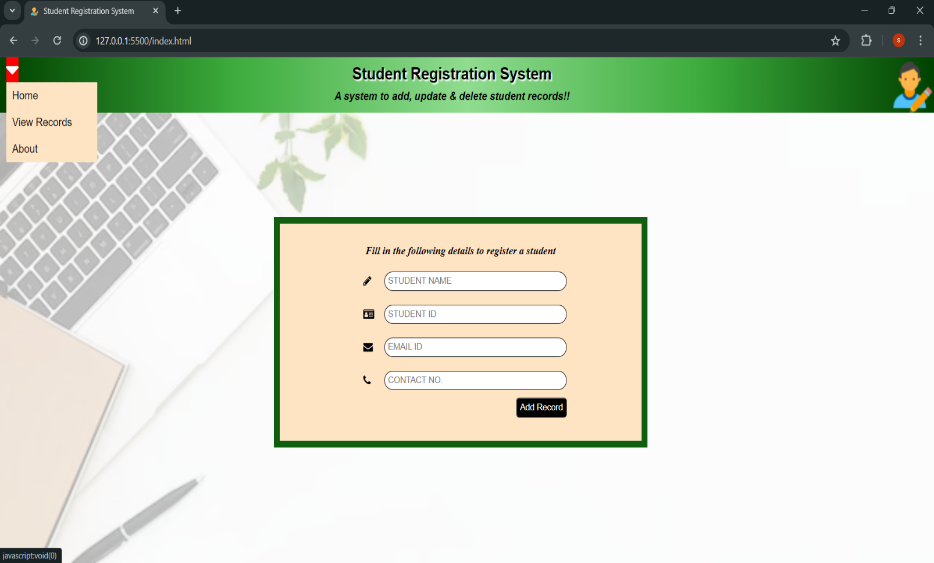

icon

description

Heading

Navigation dropdown list

Registration form

viewRecords.html -> View records page.

The records are arranged as per the order of insertion

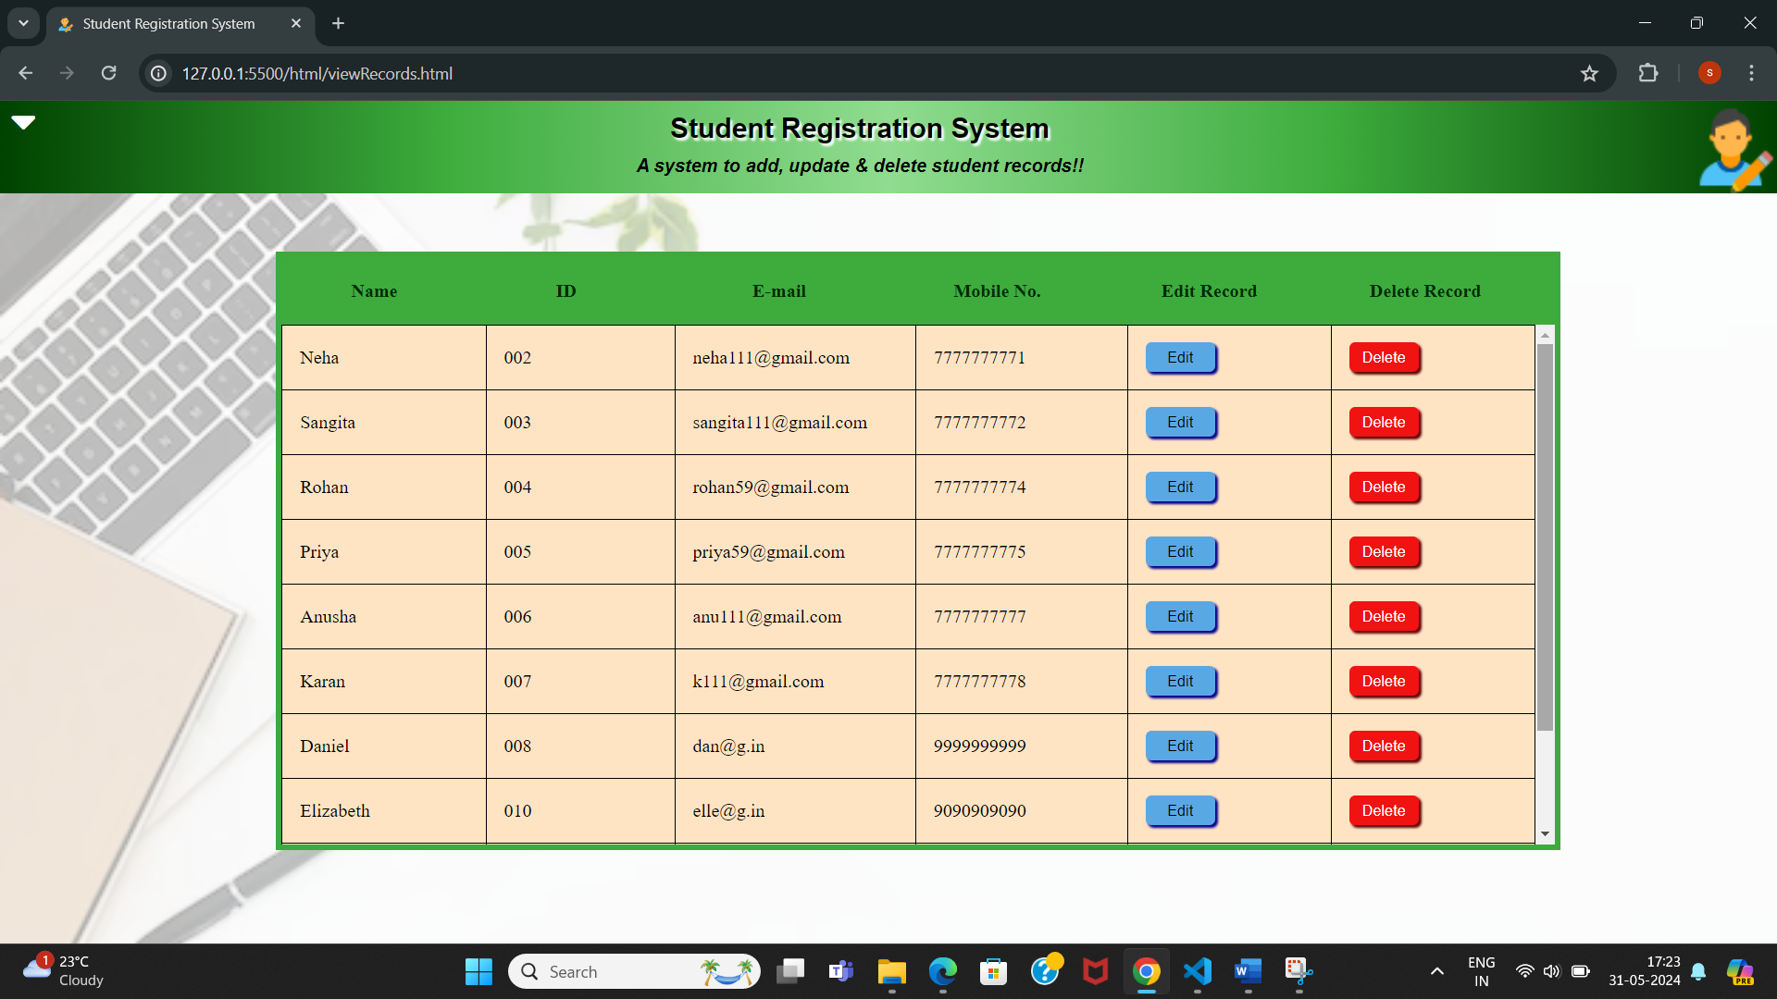

Delete record button

Edit record button

Records Table

Dynamic scroll bar

On clicking edit button, a form to enter updated information opens, as shown below:

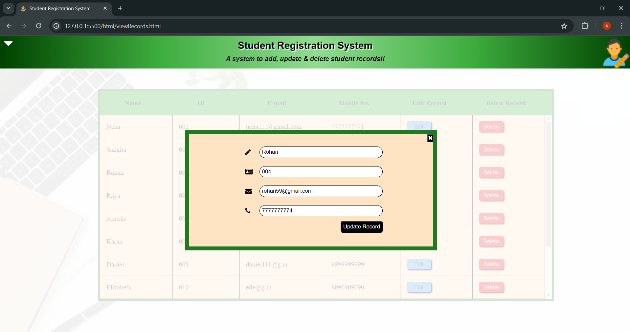

about.html -> about page: shows a brief description of the system

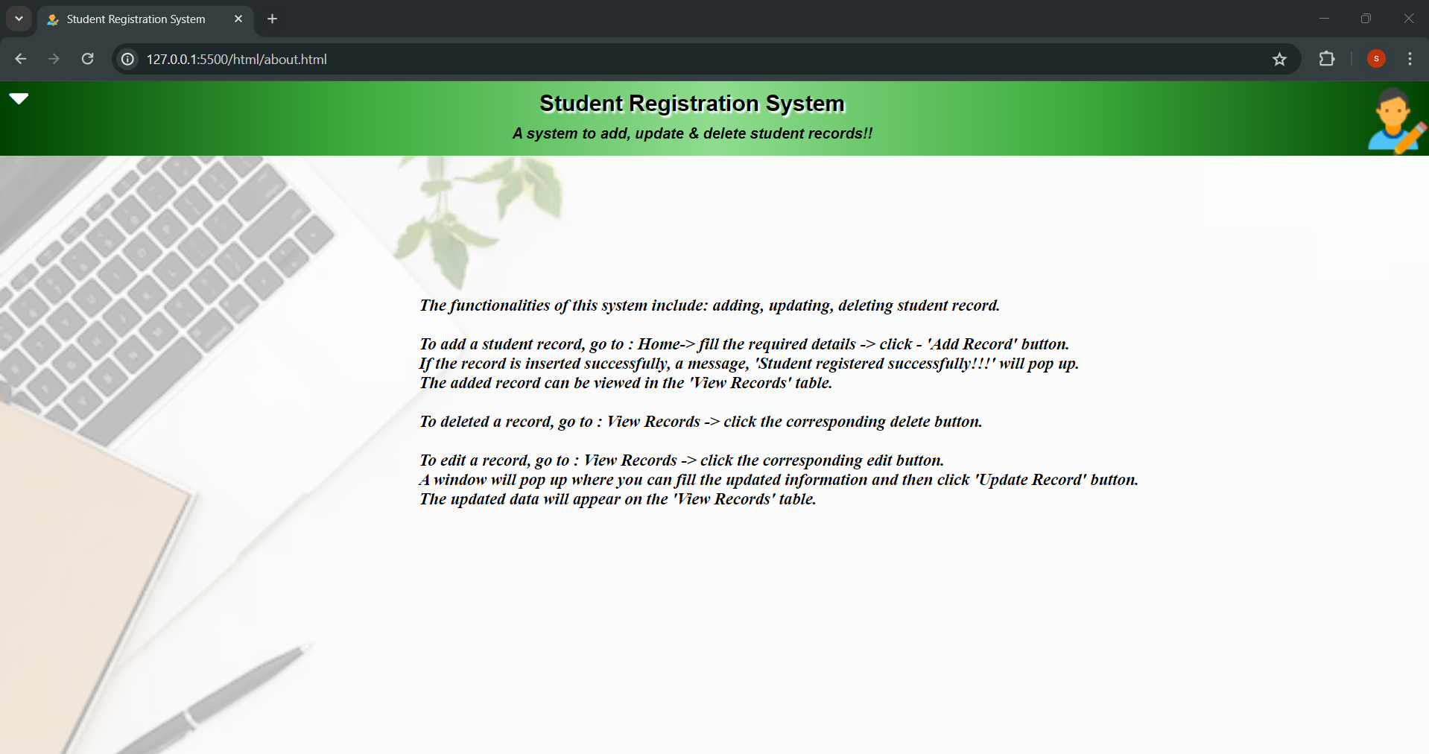

GITHUB LINK: https://github.com/SS11146111/student-registration-system.git